Allosteric mapping of human prion protein by computational methods
Reagan Womack
Several technologies are now available that can predict the location of allosteric binding sites and results of amino acid substitutions. One possible research approach uses such technologies to map out target binding sites and possibly even reverse the effects of an amino acid substitution. This can prove useful in the field of model-informed drug development. If an allosteric site can be identified and modeled, synthetic drugs can be modeled to fit the target site prior to chemically synthesizing the compound in lab. Computing the effects of amino acid substitutions (as opposed to observing them in lab) reduces the amount of time spent on refining synthesized drug molecules. If it is known what effect certain amino acid substitutions have on the binding affinity of a protein and its ligand, negative effects from some missense mutations may be avoided altogether. An allosteric map can prove to be very useful in model-informed drug development as it allows for more specific targeting of the issue at hand, rather than simply treating symptoms. Further development in complex machine learning algorithms is still needed to have a more detailed understanding of allosteric landscapes₁₇.
Cellular prion protein, while not fully understood, is known to aggregate upon mutation and cause devastating neurodegenerative diseases such as Alzheimer’s, Creutzfedt-Jakob disease, and Mad Cow Disease (bovine spongiform encephalopathy)₁₃. Current computing technologies allow for the cellular human prion protein (PrP^{C}) to be modeled and for potential allosteric sites to be identified. Binding to these allosteric sites can then be simulated in normal and variant types of PrP. I hope to create an allosteric map of PrP^{C} and its infectious mutations to describe potential targets for drug development and identify approaches to prevent prion aggregation.
PRIONS AND PRION DISEASES
Prion diseases are a class of neurodegenerative disorders caused by prions₁₄. Prion agents are abnormal isoforms of human prion protein – a cell surface protein present expressed in the nervous system₁₄. These abnormal isoforms differ from the normal protein only in their secondary structure (with an exception for inherited cases), meaning the amino acid sequence remains the same in the abnormal isoform₁₄. The conformational conversion of the normal prion protein (PrP^{c}) into the abnormal isoform (PrP^{Sc}) is the cause of these prion diseases₁₃. PrP^{Sc} tends to aggregate into amyloid fibrils, as shown in Figure 1.
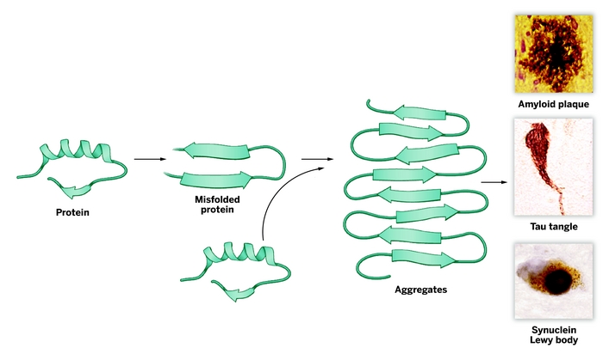
Figure 1. Modeling neurodegeneration caused by prions₂₀
These amyloid fibrils have also shown to be infectious, which explains why prion diseases are degenerative and worsen over time₄. There currently is no therapy developed to target these infectious prions
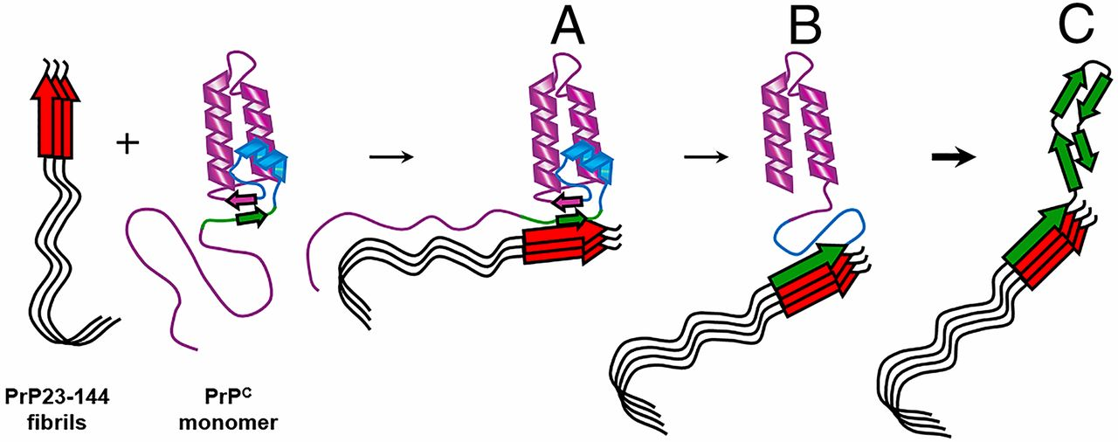
Figure 2. Amyloid fibrils from prion protein are infectious₄
The actual function of normal cellular prion protein is not well understood and only a surface level understanding is available for the function of PrP^{C} in the peripheral nervous system₂₁. PrP^{C} is highly expressed in both the peripheral nervous system and the central nervous system, which explains why the aggregation of mutant variants leads to neurodegenerative diseases. While the function of PrP^{C} is still being investigated, it is proposed to have a physiological role in sleep, memory formation, calcium homeostasis, and many other cellular regulation systems₂₁.
PrP^{C} has no known active site, however missense mutations that form prions do have a region that acts as an active site to result in prion aggregation. This “active site” on the mutated prion protein can then be used in various programs to predict and target potential allosteric sites.
ALLOSTERY AND MISSENSE MUTATIONS
A protein’s activity is regulated primarily by its active site. When the protein’s unique ligand binds to the active site, a shape change is induced so that the protein can be used to do work. Separate from the active site, proteins also have supplemental binding sites called allosteric binding sites. Allosteric binding sites don’t usually control the protein’s activity altogether but can affect the protein’s overall activity. When a ligand binds to an allosteric binding site, like with the active site, a shape change occurs that increases or decreases the protein’s activity. Allosteric binding sites can also affect the thermodynamics of a cellular reaction when the protein in question is involved.
One possible cause of inherited disorders is missense mutations. Missense mutations, defined as a single base pair substitution, cause a different amino acid to be coded into the polypeptide. This is often referred to as an amino acid substitution. This mutation can cause improper folding of the polypeptide into its final conformation in the protein, which can have disastrous effects. Proper protein folding allows the protein to carry out its function and bind with other molecules in the most thermodynamically favorable way.
Missense mutations may or may not affect the conformation of an allosteric binding site. Since proteins are made up of multiple polypeptide chains, a missense mutation may only affect one domain or subunit of the protein. If an allosteric binding site is on a separate subunit, then it likely won’t be affected by the missense mutation.
A missense mutation can also alter the effect of a ligand binding to an allosteric binding site. One example of this is outlined in Hu et. al₇. In this article, wild-type and mutant receptors were compared in the protein activity following the binding of a compound related to Arey et. al.’s Compound 1 to the Human Ca²⁺ Receptor₂. It was found that the related compound acted “as a negative allosteric modulator on the wild-type receptor but as a positive modulator” on the mutant receptor₇. In another article studying some of the same conditions and body systems, it was found that allosteric modulation instead rectified signaling abnormalities caused by mutations on the associated GPCRs₃.
Allosteric modulators are molecules that bind to a receptor to alter the receptor’s response to a stimulus. One study has shown that GPCR modulation has the possibility to overcome abnormalities such as those caused by missense mutations indirectly₃. In other words, binding to an allosteric site may rectify the effects of a mutation that occurs on a separate location on the molecule.
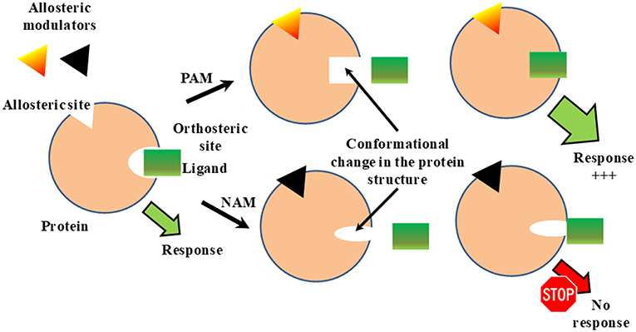
Figure 3. Overview of the function of positive (PAM) and negative (NAM) allosteric modulators₁₆
Allosteric modulators are also reversible, meaning that they can be added or removed from the target protein to regulate protein activity and subsequent substrate binding₁₁. This is especially important in the case of PrP. Since the ultimate goal is to find a way to prevent prion aggregation, a reversible modulator allows for other regulatory molecules to bind to the same molecule₁₁. Once an allosteric modulator binds to a protein and a shape change occurs, several different options are available to regulate the protein. Additional modification of the protein can occur through covalent modification. A simple modifying group can be added to the protein, aided by the conformation change induced by the allosteric modulator, that could help the protein fold back into the native conformation. The same approach can be used to modify the mutant amino acid into one that doesn’t have such a disastrous effect. Another form of covalent modification is ubiquitination, which tags the protein for degradation₁₁. This could be especially useful as it reduces the risk of the protein misfolding when modification is no longer possible.
ALLOSTERIC MAPPING BY COMPUTATIONAL METHODS
If the effects of mutations and subsequent allosteric binding and modulation is able to be predicted and simulated using digital software, in-lab experimentation can be reduced and more specific. Once a condition is studied fully and mapped out using digital software, a very specific molecule can be modeled to fit into the appropriate allosteric binding site to reverse the effects of some disease-related missense mutations.
An allosteric map displays a summary of a protein’s binding sites, the effect of amino acid substitutions on the protein’s function, and the relative location of allosteric sites to its functional site₈. This is not all that an allosteric map can display and it is largely up to the researcher to determine what will go in their allosteric map. Statistical analyses of allosteric binding, annotated models of the protein and/or significant mutated proteins, detailed models of individual functional sites, or any other data that could be deemed important to note can also be included in an allosteric map. An example of an allosteric map of the Gsp1 GTPase switch derived by Mathy et. al. is shown in Figure 4₈.
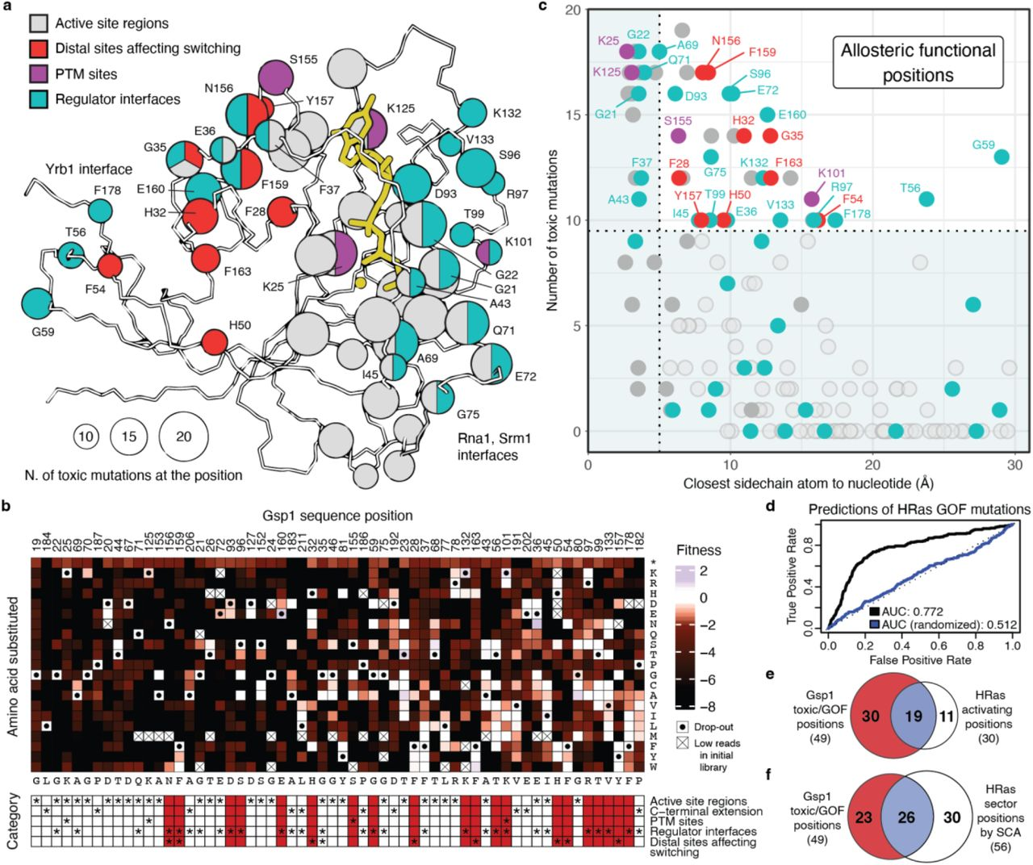
Figure 4. Allosteric map of the Gsp1 GTPase switch₈
Programs that can help contribute data to an allosteric map are described below. Most of these programs are free and available as a web server that can be run on just about any system.
Eris Suite
The Eris suite is an online server that predicts the stability of a protein following an amino acid substitution at one or more sites. Eris evaluates the given amino acid substitution and calculates the stability change in the protein induced by the given mutation(s). This calculation is returned as a value ΔΔG that can be used to identify infectious mutations₁₂. Eris also returns a new PDB file of the mutated protein.
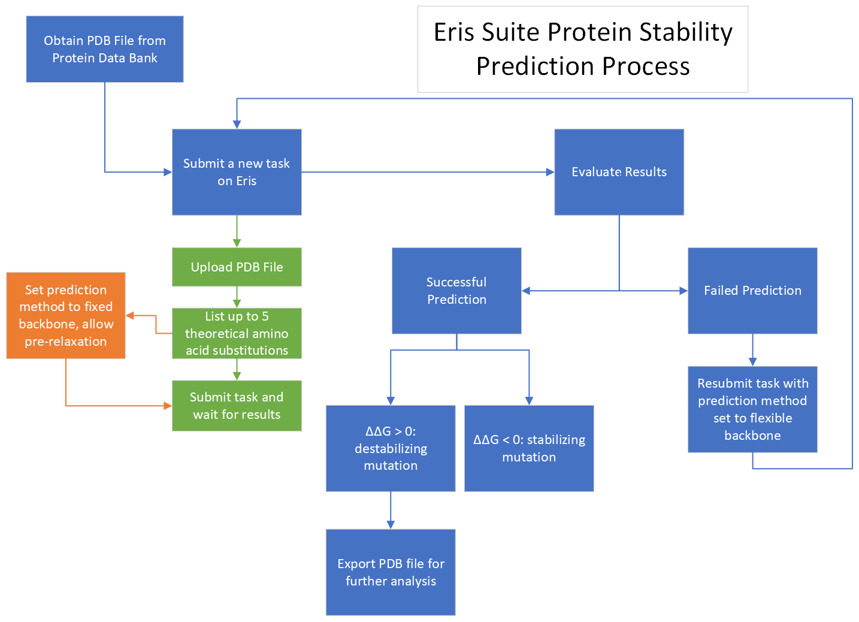
Figure 5. Flowchart showing the process of using the Eris suite
Ohm
Ohm is an online server that facilitates four aspects of allosteric analysis: prediction of allosteric sites, identification of allosteric pathways, identification of critical residues in allosteric pathways, and prediction of allosteric correlations between pairs of residues₁₈. An overview of the process of using Ohm can be seen in Figure 3, with further explanation available in Wang et al₁₈.
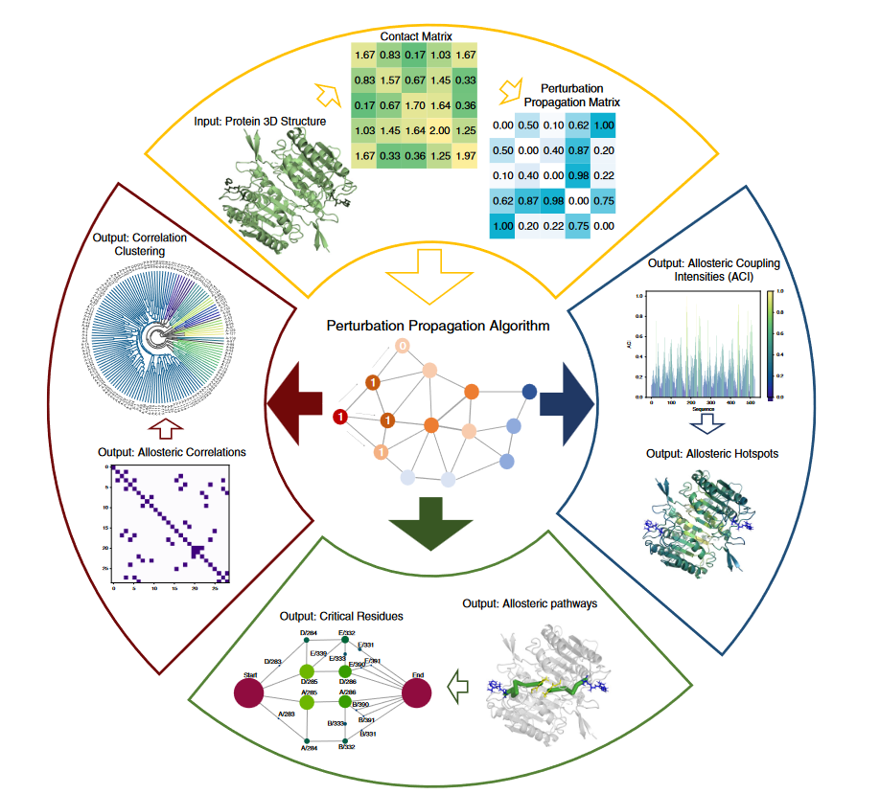
Figure 6. The Ohm Workflow₁₈
SPACER
The SPACER server allows for exploratory analysis of allosteric communication by using a provided PDB file and predicting the results of allosteric binding. Allosteric communication between multiple sites can be explored using SPACER via leverage coupling, which provides a quantitative characteristic of allosteric communication₅. Having a quantitative result alongside a digital model of the effects allows for data to be visually and mathematically analyzed and interpreted.
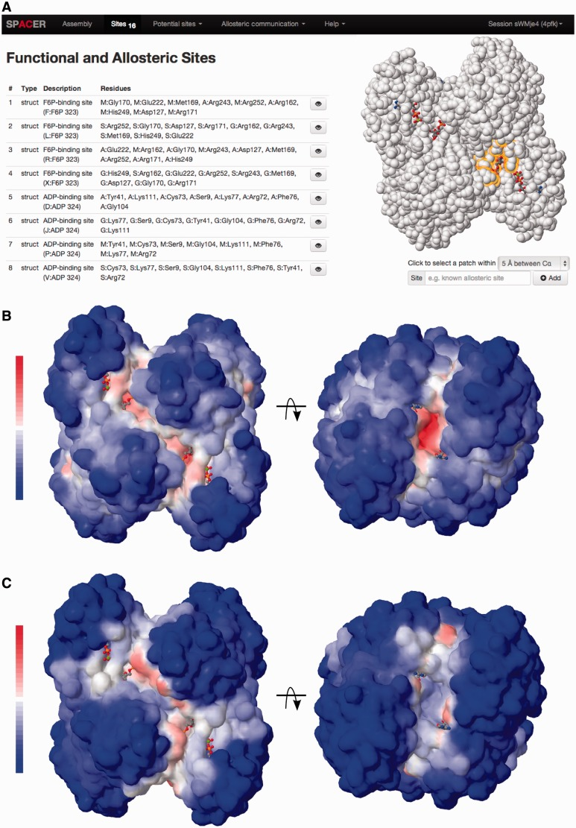
Figure 7. Screenshot of SPACER showing some of the provided tools₅
PyMOL
PyMOL is an open source molecular visualization program₁₅. PyMOL allows the user to create highly detailed renders of molecular models from a provided file (PDB or other format). The model can then be visually manipulated and annotated before being exported into various formats. Depending on the format, the exported image(s) can be embedded into websites as interactive diagrams or added to presentations and publications as still images₁₅.
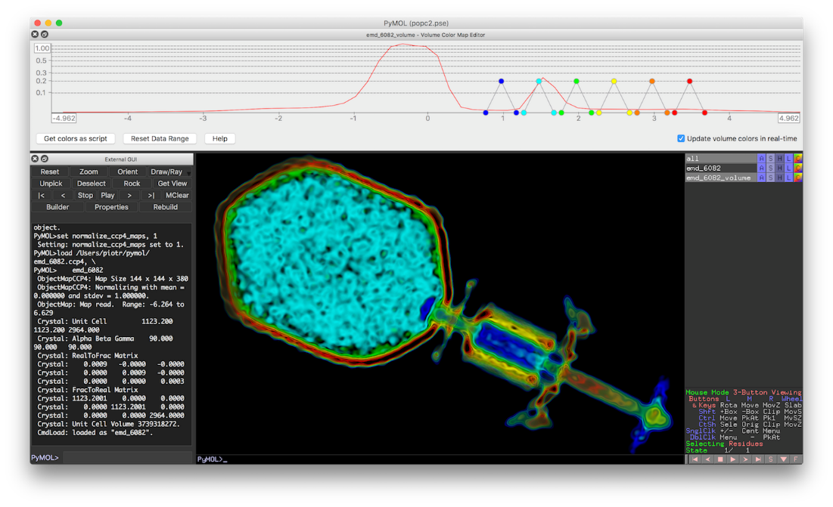
Figure 8. Screenshot from PyMOL program₁₅
ProteinLens
“ProteinLens constructs a fully atomistic, energy-weighted graph representation of a biomolecular structure and explores the long-range communication or connectivity between any specific sites in the system₁₉”.
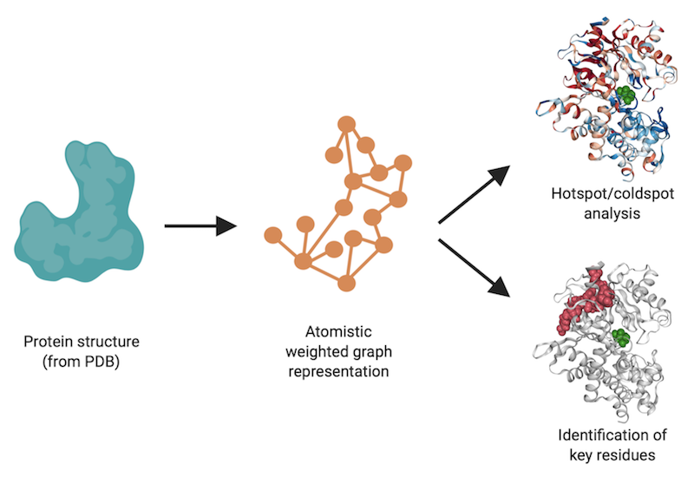
Figure 9. Graphical abstract of the applications of ProteinLens₁₉
AlloSigMA 2
The AlloSigMA 2 server is an interactive platform that aids in the exploration of allosteric signaling from ligand binding and/or mutations. AlloSigMA 2 can also be used to computationally design allosteric effectors₆.
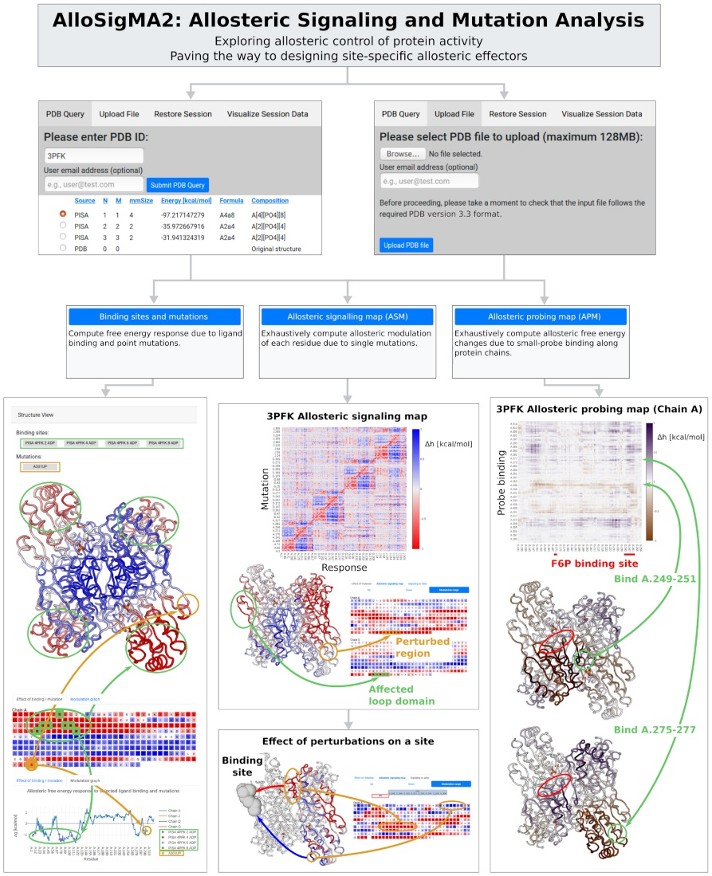
Figure 10. Flowchart of the navigation through the AlloSigMA 2 server₆

Interactome3D
Interactome3D is a web service that can be used to annotate protein interaction networks. This server provides structural detail for over 12,000 protein-protein interactions in various model organisms but also allows researchers to upload their own interactions for annotation. Interactome3D provides templates to create three-dimensional models in a fully automated manner₁₀.
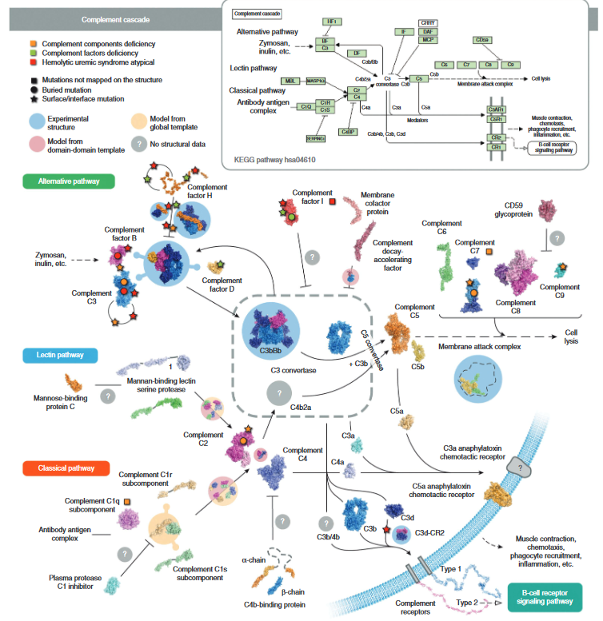
Figure 11. Example of an annotated pathway done in Interactome3D₁₀
CURRENT WORKING RESEARCH PLAN
The structure of Human Prion Protein is currently available to view on the protein data bank website (PDBID 1I4M)₁. Redler et. al. used this protein in their study using the Eris suite for the identification of missense mutations in various inherited disorders₁₂. This protein was chosen because it is relatively small and has a relatively low number of disease-associated amino acid positions compared to neutral positions (Figure 12). PrP also has more than 1 protein subunit, which means it does have quaternary structure so the effects of mutations on subunits separate from an allosteric binding site can be analyzed.
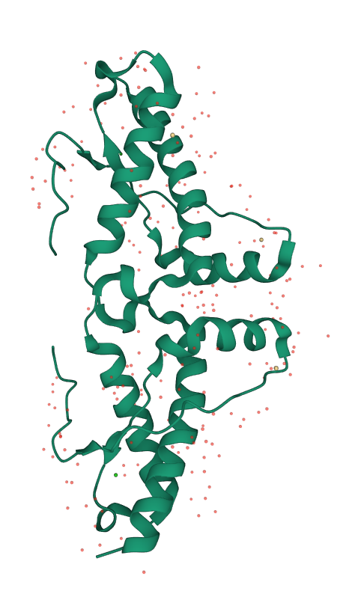
Figure 12. Structure of human prion protein₂₂
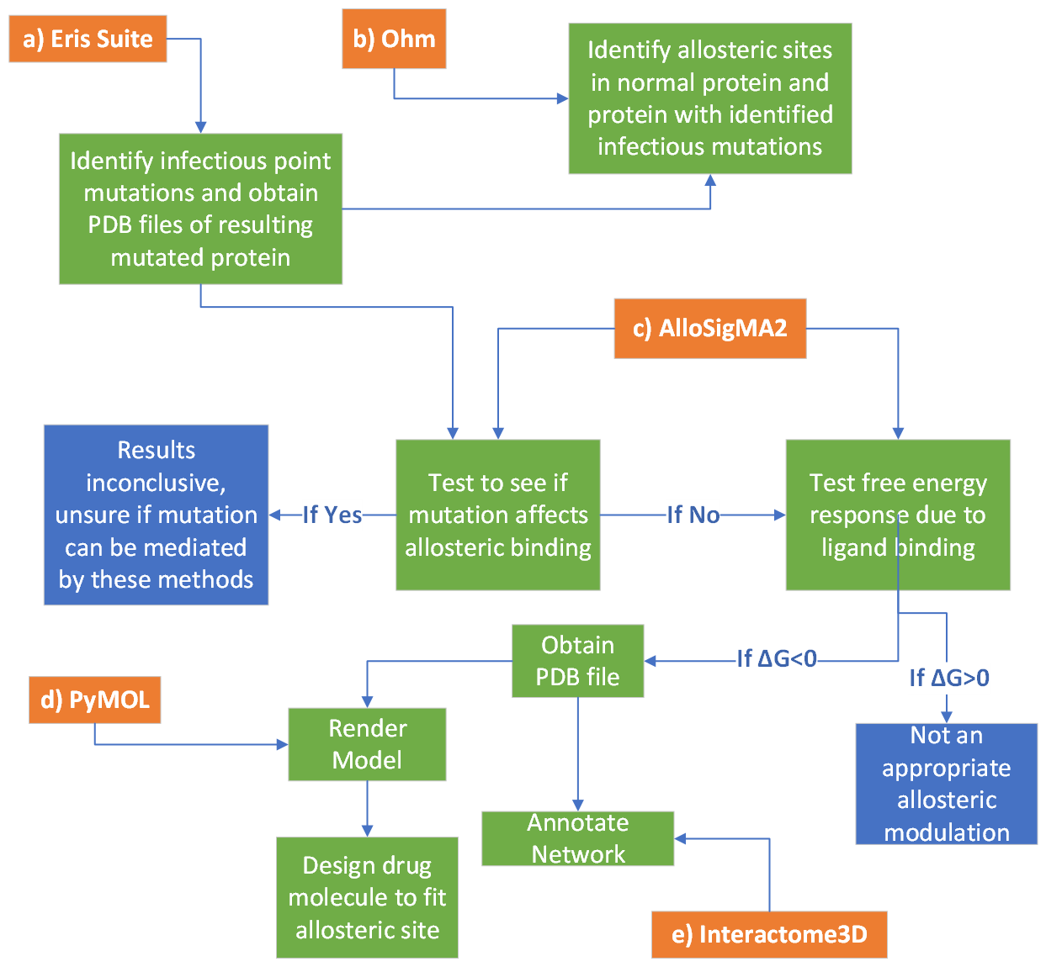
Figure 13. Flowchart of current research plan.
Figure 13 shows an outline of the current research plan. Orange boxes indicate different programs and blue boxes indicate points where analysis stops and won’t be included in the final allosteric map. The PDB file of PrP can be downloaded from the protein data bank and uploaded to Eris. Once uploaded to the Eris suite, the effects of missense mutations at every residue can be predicted. Eris provides a ΔΔG value for each mutation which indicates an infectious mutation when negative. Mutations with negative ΔΔG values will be considered “critical mutations” so PDB files for each critically mutated PrP will be obtained from Eris and uploaded to Ohm along with the wild type PrP. The effect of each amino acid substitution at each residue will be tested and analyzed to be used later in the research. In Ohm, allosteric sites can be predicted with the location of the mutation set as the active site. For normal PrP, each infectious mutation site will be used individually as the active site for predicting allosteric sites.
With the data obtained from Eris and Ohm, exploratory analysis of missense mutations and subsequent allosteric binding can be analyzed using AlloSigMA2. AlloSigMA2 will show if the mutations identified by Eris affect the allosteric binding from the normal protein. If the allosteric binding is not affected, the free energy response due to ligand binding at the target allosteric site can be predicted using AlloSigMA2. If the change in free energy is negative, the binding of a ligand to the allosteric site is predicted to mediate the effects of the misfolded prion protein. This can be repeated with other misfolded PrP and allosteric binding sites to obtain a quantitative map of the effects of missense mutations and subsequent allosteric binding of PrP.
Once the quantitative map is acquired, statistical analysis of the results can be performed to determine the significance of allosteric binding on the effects of PrP protein misfolding. Analysis results can provide information to help determine the effectiveness of this method in predicting a reversal effect on the abnormal isoform of PrP.
Once appropriate allosteric modulation is identified for the various infectious mutations, a PDB file can be obtained and uploaded to PyMOL and Interactome3D for observation and network annotation. In PyMOL, a drug molecule can also be designed to fit the target allosteric site. The resulting data and figures will be compiled into an allosteric map.
BUDGET
Only one program needs to be purchased for this research:
PyMOL + AxPyMOL – Professional License (1 person): $148/year₁₅

REFERENCES
- 1I4M. (n.d). Protein Databank. https://www.rcsb.org/structure/1i4m
- Arey, B. J., Seethala, R., Ma, Z., Fura, A., Morin, J., Swartz, J., Vyas, V., Yang, W., Dickson, J. K., & Feyen, J. H. M. (2005). A novel calcium-sensing receptor antagonist transiently stimulates parathyroid hormone secretion in vivo. Endocrinology (Philadelphia), 146(4), 2015-2022. https://doi.org/10.1210/en.2004-1318
- Babinsky, V. N., Hannan, F. M., Gorvin, C. M., Howles, S. A., Nesbit, M. A., Rust, N., Hanyaloglu, A. C., Hu, J., Spiegel, A. M., & Thakker, R. V. (2016). Allosteric modulation of the calcium-sensing receptor rectifies signaling abnormalities associated with G-protein α-11 mutations causing hypercalcemic and hypocalcemic disorders. The Journal of Biological Chemistry, 291(20), 10876-10885. https://doi.org/10.1074/jbc.M115.696401
- Choi, J., Cali, I., Surewicz, K., Kong, Q., Gambetti, P., & Surewicz, W. K. (2016). Amyloid fibrils from the N-terminal prion protein fragment are infectious. Proceedings of the National Academy of Sciences - PNAS, 113(48), 13851-13856. https://doi.org/10.1073/pnas.1610716113
- Goncearenco, A., Mitternacht, S., Yong, T., Eisenhaber, B., Eisenhaber, F., & Berezovsky, I. N. (2013). SPACER: Server for predicting allosteric communication and effects of regulation. Nucleic Acids Research, 41(Web Server issue), W266-W272. https://doi.org/10.1093/nar/gkt460
- Guarnera E, Tan ZW, Zheng Z, Berezovsky IN. AlloSigMA: allosteric signaling and mutation analysis server. Bioinformatics. 2017 Dec 15;33(24):3996-3998. doi: 10.1093/bioinformatics/btx430. PMID: 29106449.
- Hu, J., Jiang, J., Costanzi, S., Thomas, C., Yang, W., Feyen, J. H. M., Jacobson, K. A., & Spiegel, A. M. (2006). A missense mutation in the seven-transmembrane domain of the human Ca2+ receptor converts a negative allosteric modulator into a positive allosteric modulator. The Journal of Biological Chemistry, 281(30), 21558-21565. https://doi.org/10.1074/jbc.M603682200
- Mathy, C., Mishra, P., Flynn, J., Perica, T., Mavor, D., Bolon, D., & Kortemme, T. (2022). Complete mutational mapping of a GTPase switch in vivo reveals novel allosteric regulation. (). Cold Spring Harbor: Cold Spring Harbor Laboratory Press. https://doi.org/10.1101/2022.04.13.488230 Retrieved from Publicly Available Content Database https://search.proquest.com/docview/2650105208
- Mitra, A., & Wang, Y. (2022). Applications of model informed drug development (MIDD) in drug development lifecycle and regulatory review. Pharmaceutical Research, 39(8), 1663-1667. https://doi.org/10.1007/s11095-022-03327-6
- Mosca, R., Céol, A., & Aloy, P. (2013). Interactome3D: Adding structural details to protein networks. Nature Methods, 10(1), 47-53. https://doi.org/10.1038/nmeth.2289
- Nelson, D. L., Cox, M. M., & Hoskins, A. A. (2021). Regulatory enzymes. In C. Korsvik, & K. Hughes (Eds.), Lehninger principles of biochemistry (pp. 213-216). Macmillan Learning.
- Redler, R. L., Das, J., Diaz, J. R., & Dokholyan, N. V. (2016;2015;). Protein destabilization as a common factor in diverse inherited disorders. Journal of Molecular Evolution, 82(1), 11-16. https://doi.org/10.1007/s00239-015-9717-5
- Sakaguchi, S. (2022). Prion pathogenesis revealed in a series of the special issues “Prions and prion diseases”. International Journal of Molecular Sciences, 23(12), 6490. https://doi.org/10.3390/ijms23126490
- Sánchez-Valle, R. (2022). Prion diseases. European Neuropsychopharmacology, 55, 1-3. https://doi.org/10.1016/j.euroneuro.2021.09.008
- Schrödinger. (n.d.). PyMOL. https://pymol.org
- Vavers, E., Zvejniece, L., Maurice, T., & Dambrova, M. (2019). Allosteric modulators of sigma-1 receptor: A review. Frontiers in Pharmacology, 10, 223-223. https://doi.org/10.3389/fphar.2019.00223
- Verkhivker, G. M. (2021). Making the invisible visible: Toward structural characterization of allosteric states, interaction networks, and allosteric regulatory mechanisms in protein kinases. Current Opinion in Structural Biology, 71, 71-78. https://doi.org/10.1016/j.sbi.2021.06.002
- Wang, J., Jain, A., McDonald, L. R., Gambogi, C., Lee, A. L., & Dokholyan, N. V. (2020). Mapping allosteric communications within individual proteins. Nature Communications, 11(1), 3862-3862. https://doi.org/10.1038/s41467-020-17618-2
- Welcome to ProteinLens. (n.d). ProteinLens. https://www.proteinlens.io/webserver/
- Wolf, L.K. (2012, July 2). Alzheimer’s Prion Connection. C&EN. https://cen.acs.org/articles/90/i27/Alzheimers-Prion-Connection.html
- Wulf, M., Senatore, A., & Aguzzi, A. (2017). The biological function of the cellular prion protein: An update. BMC Biology, 15(1), 34-34. https://doi.org/10.1186/s12915-017-0375-5
- Yee, V. C., Knaus, K. J., Morillas, M., Swietnicki, W., Malone, M., & Surewicz, W. K. (2001). Crystal structure of the human prion protein reveals a mechanism for oligomerization. Nature Structural & Molecular Biology, 8(9), 770-774. https://doi.org/10.1038/nsb0901-770

